

A MINI PROJECT REPORT

On

QUIZ APPLICATION

Submitted in partial fulfillment of the requirement of University of Mumbai for the Course

**In**

# Computer Engineering (IV SEM)

Submitted By

**Aditya Yadav**

**Shauryan Singh**

**Viraj Jadhav**

Subject In-charge

(**Merlin Priya Jacob**)



**CERTIFICATE**

This is to certify that the requirements for the project report entitled ‘**Quiz Application**’ have been successfully completed by the following students:

|  |  |
| --- | --- |
| **Name** | **Moodle Id** |
| Aditya Yadav | 19102006 |
| Shauryan Singh | 19102004 |
| Viraj Jadhav | 19102022 |

In partial fulfilment of the course **Skill Based Lab Course:** **Python Programming (CSL 405)** in Sem: IV of Mumbai University in the Department of Computer Engineering during academic year 2020-2021.

Sub-in-Charge

**(Merlin Priya Jacob)**

# 

# PROJECT APPROVAL

The project entitled ‘**Quiz Application**’ by **Aditya Yadav, Shauryan Singh** and **Viraj Jadhav** are approved for the course of **Skill Based Lab Course:** **Python Programming (CSL 405)** in Sem: IV of Mumbai University in the Department of Computer Engineering.

Subject-in-Charge

**(Merlin Priya Jacob)**

Date:

Place: Thane

**Table of Contents**

|  |  |  |
| --- | --- | --- |
| **Sr**. **No.** | **Topic** | **Page No.** |
| 1. | Abstract (150-200 words) | 5 |
| 2. | List of Figures | 6 |
| 3. | Problem Definition | 7 |
| 4. | Introduction | 8 |
| 5. | Description of the modules used | 9 |
| 6. | Implementation details with screen-shots | 10 |
| 7. | Conclusion and Future Scope | 17 |
| 8. | References | 18 |
| 9. | Acknowledgement | 19 |

**Abstract**

This project is based on the concept of making a ***Quiz Application*** using Python. With the help of python’s in-built packages,we were able to portray this project in a Graphical User Interface format, wherein the user has to fill in the required details, play quiz with a timer functionality and, in the end, the score will be displayed. There is also a function to add a question in the database. So, this will be an efficient and online mode of conducting the quiz. The main objective of this project is to efficiently evaluate the candidate thoroughly through a fully automated system that not only saves lot of time but also gives fast results. Candidate details, questions added (if any) and scores are stored in the database and can be fetched from the server. If the candidate is already registered in the database, then only the score will be updated rest all the data is kept constant. So, there won’t be any ambiguity. The system carries out the examination and auto-grading for multiple choice questions which is fed into the system.

**List of Figures**

Figure 1 – **Frame 1** 12

Figure 2 – **Frame 2(a)** 12

Figure 3 – **Frame 2 (b)** 13

Figure 4 – **Frame 2 (c)** 14

Figure 5 – **Frame 2 (d)** 14

Figure 6 – **Frame 3** 15

Figure 7 – **Frame 4 (a)** 15

Figure 8 – **Frame 4 (b)** 16

Figure 9 – **Frame 4 (c)** 16

Figure 10 – **Frame 5 (a)** 17

Figure 11 – **Frame 5 (b)** 17

Figure 12 – **Frame 5 (c)** 18

Figure 13 – **Frame 6** 18

**Problem Definition**

For this mini-project, we aim to develop a ***Quiz Application***wherein the candidate will be allowed to play a quiz game for a particular set of questions and will be marked based upon the correct answer. This data will be stored in the database and, if in case the same candidate is playing the game again, then only the new high score will be updated so that memory is used feasibly. The quiz will be a multiple-choice question with four options.

**Introduction**

A Quiz is a very important part of education and content revising. So, with the help of Python, we have designed a graphical user interface to allow the interested candidates to give quizzes and view their results. It is cost as well as time effective. The main aim of this project is to facilitate a user-friendly environment.

At first, a candidate will have to register themself through proposed system by entering some basic personal details like name, email id, contact number and, stream. From this inputted data, the name will be stored in the database. Once the quiz is finished there will be a score prompt in which the score of candidates with his name will be displayed. This score is now stored in the database. If a registered candidate is playing the game, then only the high score will be stored.

**Description of Modules Used:**

1. **Tkinter:** The tkinter package is the standard Python interface to the Tk GUI toolkit. It is a cross platform library.
2. **Ttk:** The tkinter.ttk module provides access to the Tk themed widget set. The basic idea for tkinter.ttk is to separate, to the extent possible, the code implementing a widget’s behavior from the code implementing its appearance. Some widgets used in our program are Frame, Message box, Radio buttons, Buttons and Labels.
3. **Message box:** The tkinter. message box, module provides a template base class as well as a variety of convenience methods for commonly used configurations. The message boxes are modal and will return a subset of (True, False, OK, None, Yes, No) based on the user’s selection.
4. **Random:** This module implements pseudo-random number generators for various distributions. For integers, there is uniform selection from a range. For sequences, there is uniform selection of a random element, a function to generate a random permutation of a list in-place, and a function for random sampling without replacement.
5. **SQLite 3:** SQLite is a C library that provides a lightweight disk-based database that doesn’t require a separate server process and allows accessing the database using a nonstandard variant of the SQL query language. Some applications can use SQLite for internal data storage. It’s also possible to prototype an application using SQLite and then port the code to a larger database such as PostgreSQL or Oracle.

**Implementation Details with Screen Shots**

Figure 1 – **Frame 1**:

This is the main Frame i.e, Home Page of our GUI based Quiz Application. It contains Play button, add question button and an exit button.

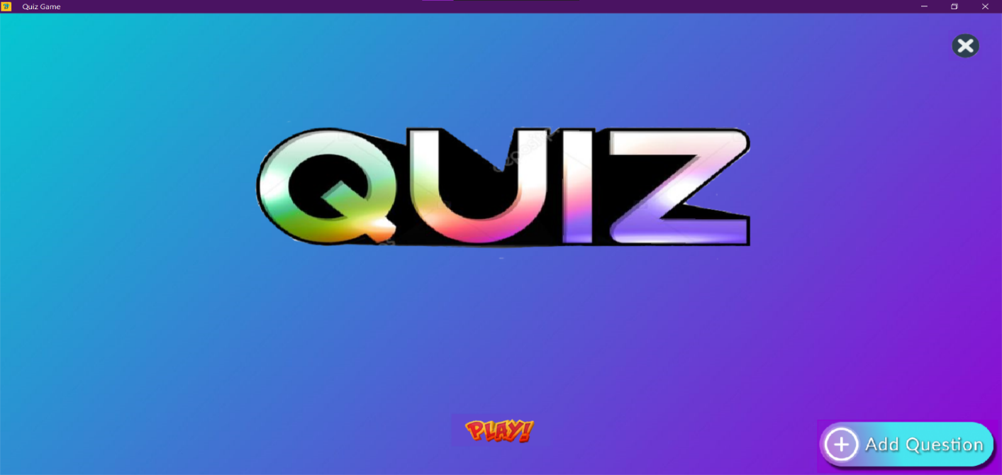

Figure 2 – **Frame 2(a)**

If the user clicks on add question button, then the Frame 2 will be displayed. In this frame user has to enter the question, there must be exactly four options separated by a comma and a correct option following it.

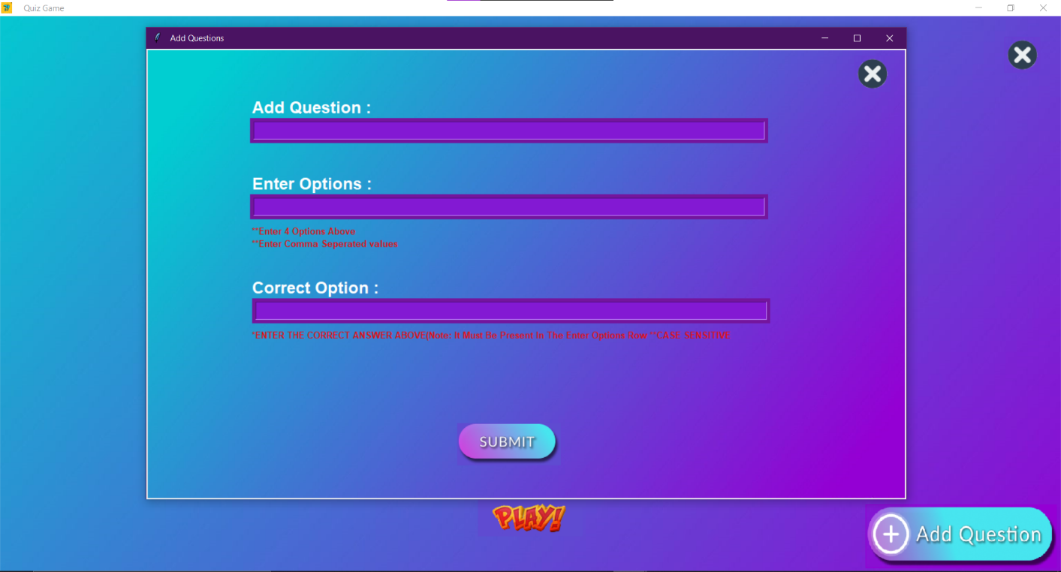

Figure 3 – **Frame 2 (b)**

Once the user inputted question and options correctly then the Label will be displayed with a success message.

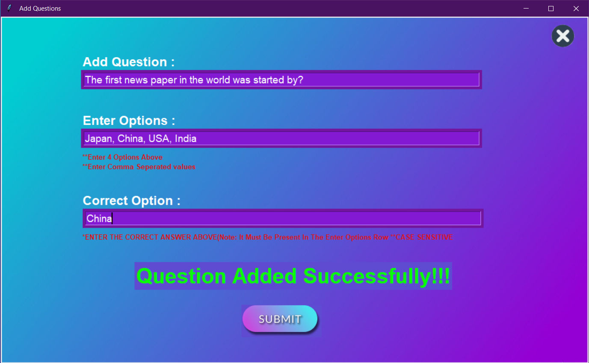

Figure 4 – **Frame 2 (c)**

If correct number of options are not entered then, there will be an error prompt shown.

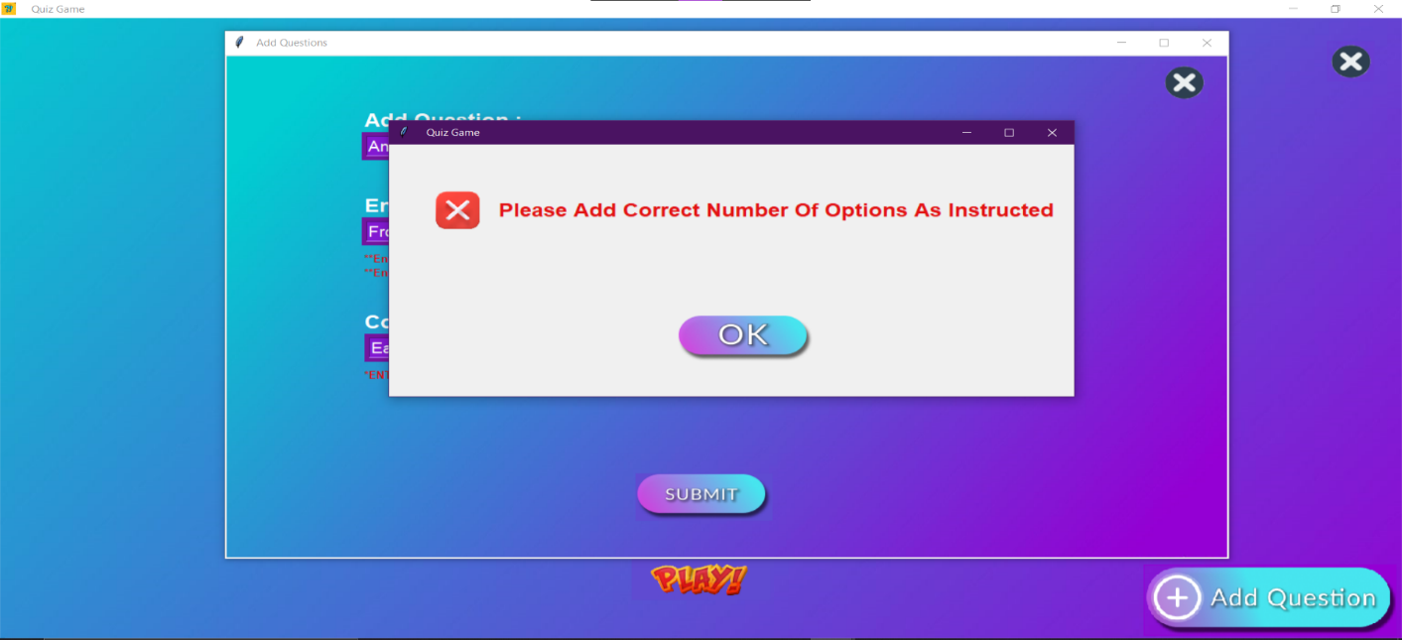

Figure 5 – **Frame 2 (d)**

If the option entered in a third row is not present amongst the four options, then this error prompt is shown.

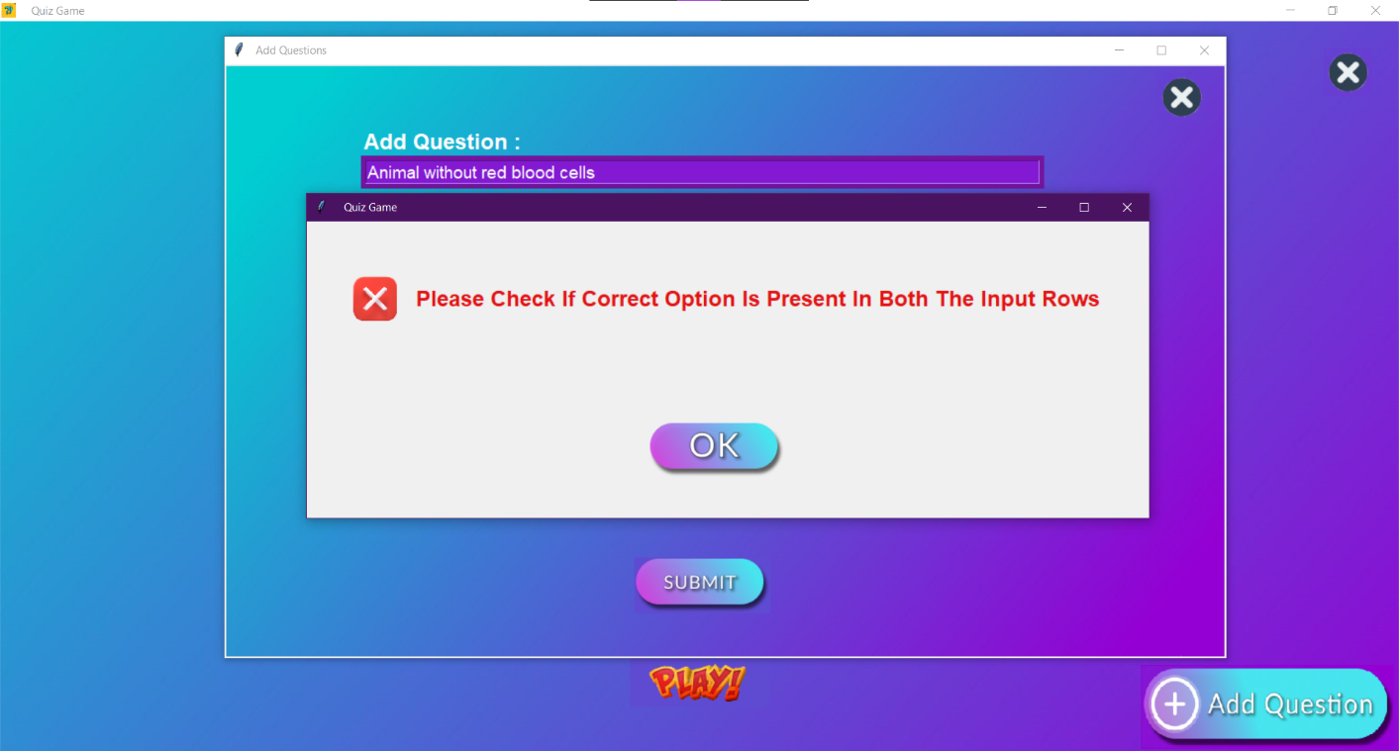

Figure 6 – **Frame 3**

After that, next frame is displayed which asks the details about the player. Player has to enter his name, email id, contact number and stream.

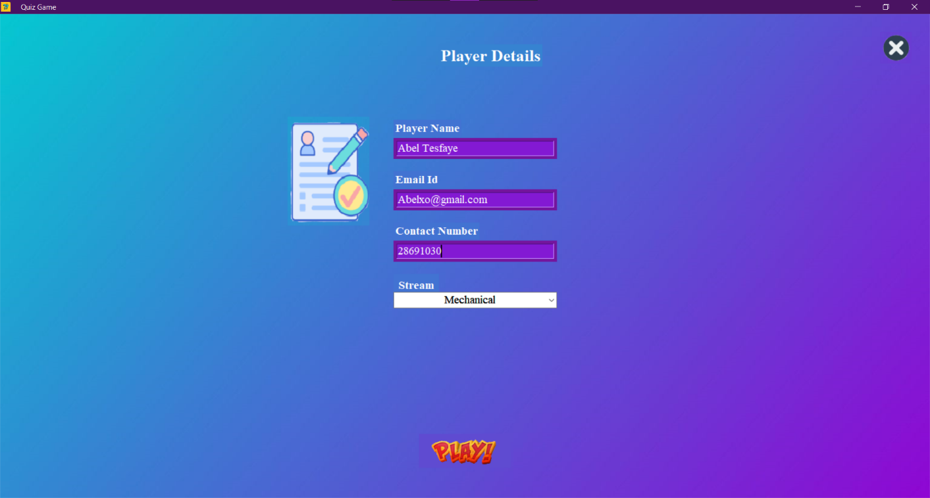

Figure 7 – **Frame 4 (a)**

After clicking on next button in the previous frame, quiz game has started. On the top right corner there is a timer and in the main label there is a question with multiple choice answers. To proceed to next question player has to click on next button.

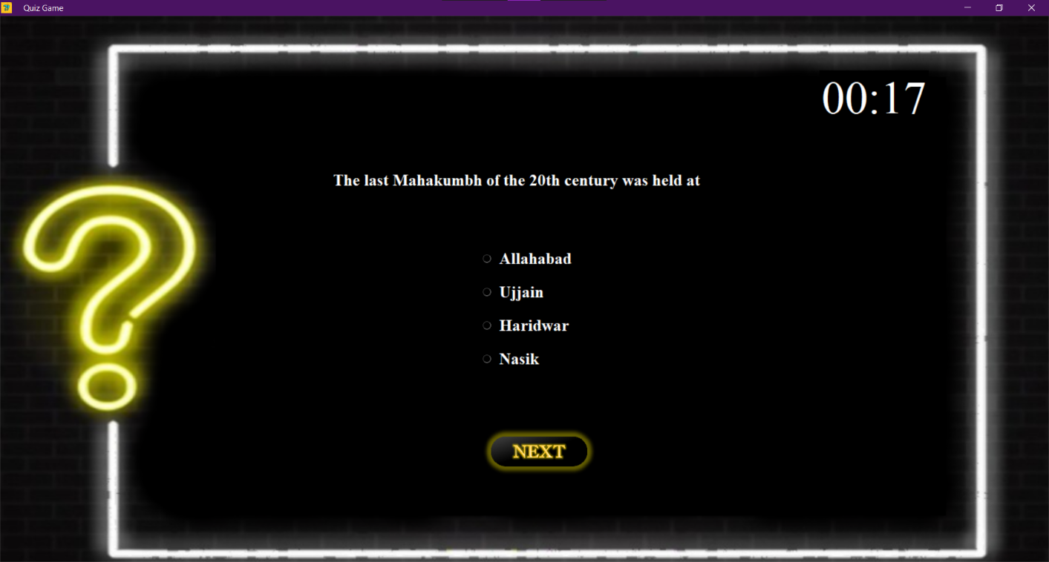

Figure 8 – **Frame 4 (b)**

This is the last question of the game. In this frame Next button is changed to Finish button.

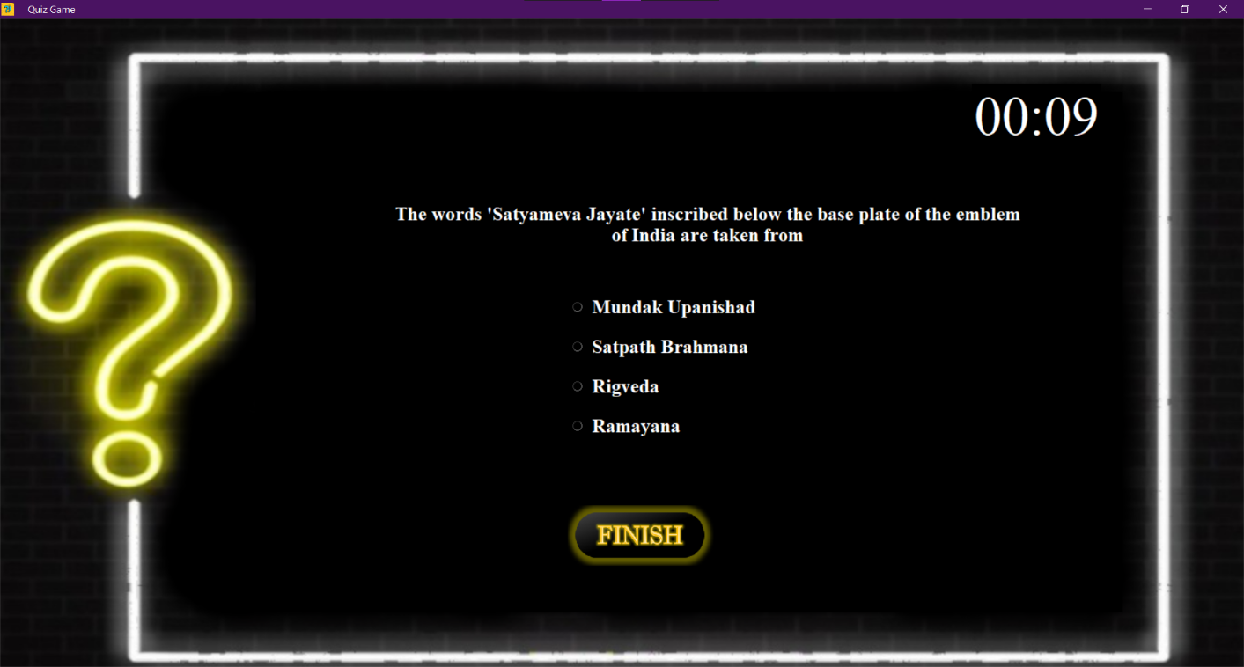

Figure 9 – **Frame 4 (c)**

Once the quiz is finished there will be a message box containing the player name and the score he got.

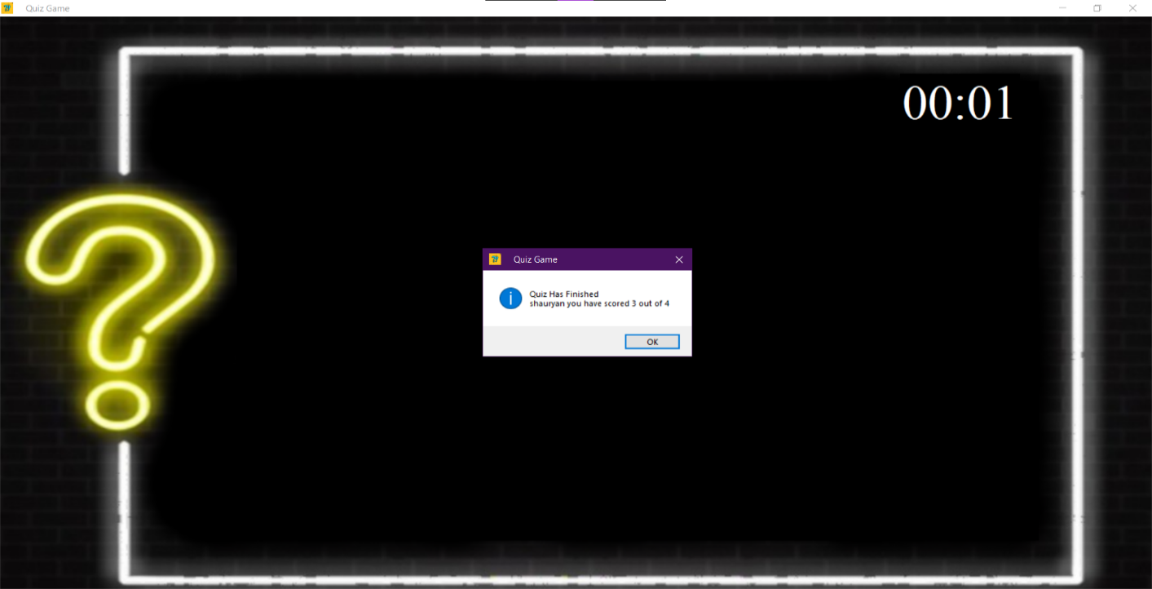

Figure 10 – **Frame 5 (a)**

If the user is able to give three correct answers, then the program will display a message i.e., Congratulations, you have passed the quiz.

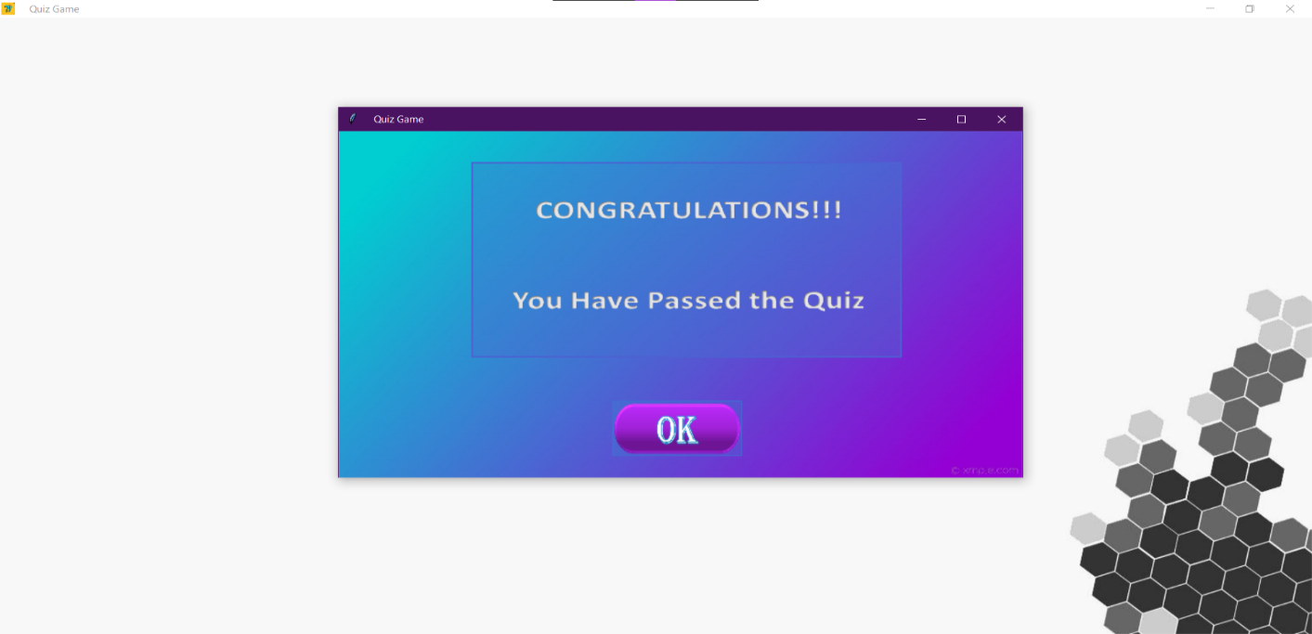

Figure 11 – **Frame 5 (b)**

If the user scores less than three, then the user has failed the quiz test an appropriate message will be displayed.

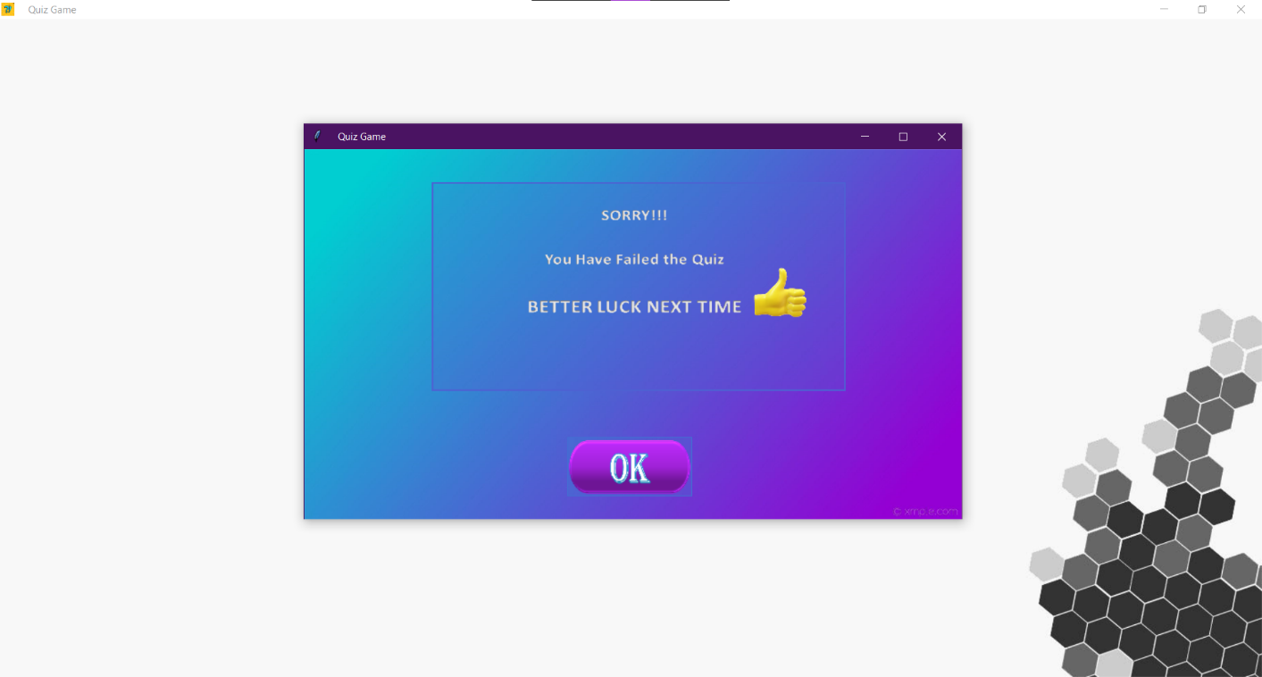

Figure 12Figure 13 – **Frame 5 (c)**

In frame 5 there are two buttons, first one is ‘back to home’ button, it will redirect the user to the home page and another is ‘view high score’ button, it will show the data of all the users who played this game and it will display the scores.

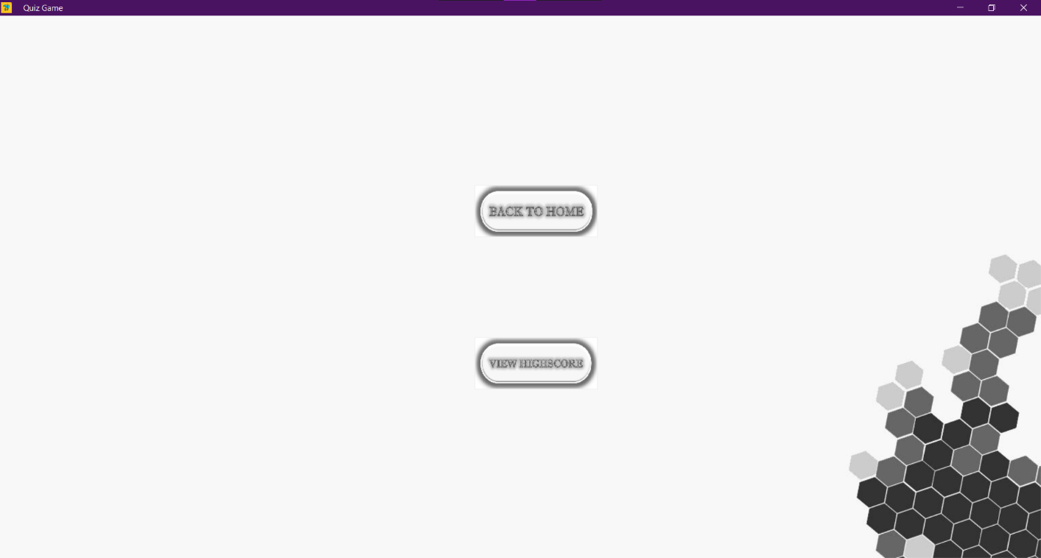

Figure 14 – **Frame 6**

This frame is showed when we click on high score button. It contains Name and Score of the player.

This data is fetched from the database which we created using SQLite.

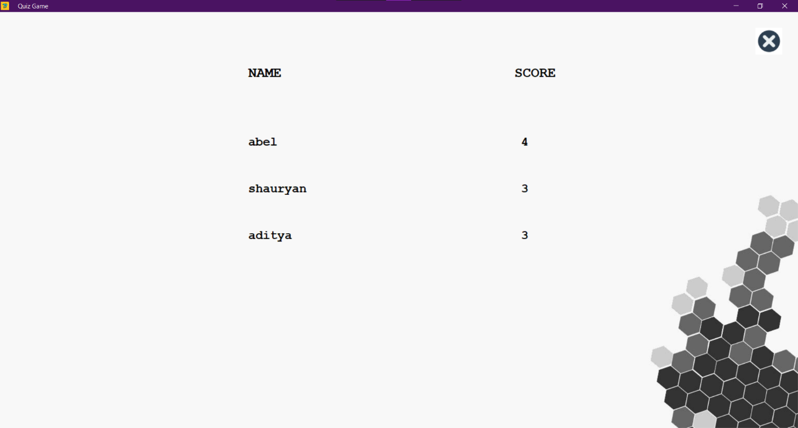

**Conclusion**

Thus, large number of participants are able to play the game, with instant results. We were successfully able to randomize the questions and set a timer. All the player data’s such as Player name and their respective scores are stored in the database. Thus, we conclude that we have successfully studied and applied the knowledge of Python GUI using Tkinter in our project.

**Future Scope**

With respect to this game, we would further like to include:

* Visual Aptitude Questions.
* We will also add questions on the basis of Player streams.

**References**

* Background image for Tkinter: <https://youtu.be/WurCpmHtQc4>
* Button Image for Tkinter: <https://youtu.be/bVnKX0315lo>
* SQLite Functions: <https://youtu.be/pd-0G0MigUA>
* Main quiz logic: <https://github.com/Shauryan23/Python-Quiz-App/blob/main/Quiz.py>
* Multiple frames: <https://www.youtube.com/watch?v=MKgDQjZwI2o>

**ACKNOWLEDGEMENT**

We have the great pleasure in presenting the mini-project report on **Quiz Application**. We would like to express our sincere regard and indebtedness to our project guide **Merlin Priya Jacob**, Department of Computer Engineering, APSIT Thane for her valuable time, guidance, encouragement, support and cooperation throughout the duration of our project. We would sincerely like to thank Computer Department for giving us the opportunity to work on enhancing our technical skills while undergoing this project. This project helped us in understanding the various parameters which are involved in the development of our project.

We thank **Prof. Sachin Malave**, Head of Department, Computer Engineering, APSIT for his encouragement during progress meeting and providing guidelines to write this report.

We also thank the entire staff of APSIT for their invaluable help rendered during the course of this work. We wish to express our deep gratitude towards all our colleagues of APSIT for their encouragement.

**Student Name 1: Aditya Yadav**

**Moodle Id: 19102006**

**Student Name 2: Shauryan Singh**

**Moodle Id: 19102004**

**Student Name 3: Viraj Jadhav**

**Moodle Id: 19102022**